Laporan Praktikum
Bahasa Pemrograman 1
Dosen pengampu : (Dede Husen, M.Kom.)

Modul 3



Nama : Muhammad Rizal Nurfirdaus
NIM : 20230810088
Kelas : TINFC – 2023 – 04

Teknik Informatika Fakultas Ilmu Komputer
Universitas Kuningan

Pre Test
- Apa itu Swing?
- Apa fungsi dari Swing?
- Tuliskan contoh program sederhana untuk Swing container dan menu!

Praktikum
- BP1_M3_P1_Rizal_Container
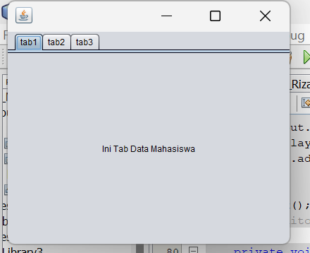
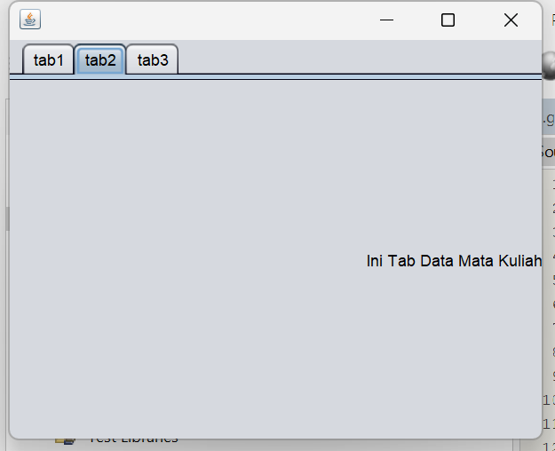
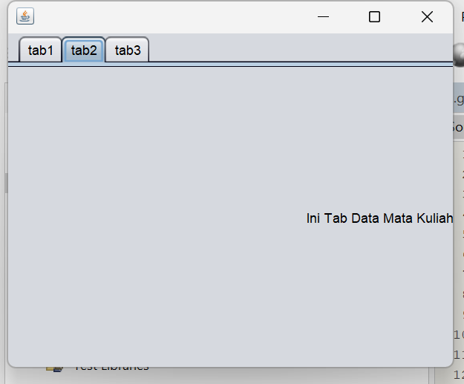

Script Code : /*

import javax.swing.JOptionPane;

/*
* To change this license header, choose License Headers in Project Properties.
* To change this template file, choose Tools | Templates
* and open the template in the editor.
*/

/**
*
* @author Muhammad Rizal Nur F
*/
public class BP1_M3_P1_Rizal_Container extends javax.swing.JFrame {

/**
* Creates new form BP1_M3_P1_Rizal_Container
*/
public BP1_M3_P1_Rizal_Container() {
initComponents();
}

/**
* This method is called from within the constructor to initialize the form.
* WARNING: Do NOT modify this code. The content of this method is always
* regenerated by the Form Editor.
*/
@SuppressWarnings("unchecked")
// <editor-fold defaultstate="collapsed" desc="Generated Code">
private void initComponents() {

jTabbedPane1 = new javax.swing.JTabbedPane();
jLabel1 = new javax.swing.JLabel();
jLabel2 = new javax.swing.JLabel();
jLabel3 = new javax.swing.JLabel();

setDefaultCloseOperation(javax.swing.WindowConstants.EXIT_ON_CLOSE);

jLabel1.setHorizontalAlignment(javax.swing.SwingConstants.CENTER);
jLabel1.setText("Ini Tab Data Mahasiswa");
jLabel1.addMouseListener(new java.awt.event.MouseAdapter() {
public void mouseClicked(java.awt.event.MouseEvent evt) {
jLabel1MouseClicked(evt);
}
});
jTabbedPane1.addTab("tab1", jLabel1);

jLabel2.setHorizontalAlignment(javax.swing.SwingConstants.RIGHT);
jLabel2.setText("Ini Tab Data Mata Kuliah");
jLabel2.addMouseListener(new java.awt.event.MouseAdapter() {
public void mouseClicked(java.awt.event.MouseEvent evt) {
jLabel2MouseClicked(evt);
}
});
jTabbedPane1.addTab("tab2", jLabel2);

jLabel3.setHorizontalAlignment(javax.swing.SwingConstants.LEFT);
jLabel3.setText("Ini Tab Data Nilai");
jLabel3.addMouseListener(new java.awt.event.MouseAdapter() {
public void mouseClicked(java.awt.event.MouseEvent evt) {
jLabel3MouseClicked(evt);
}
});
jTabbedPane1.addTab("tab3", jLabel3);

javax.swing.GroupLayout layout = new javax.swing.GroupLayout(getContentPane());
getContentPane().setLayout(layout);
layout.setHorizontalGroup(
layout.createParallelGroup(javax.swing.GroupLayout.Alignment.LEADING)
.addComponent(jTabbedPane1, javax.swing.GroupLayout.DEFAULT_SIZE, 400, Short.MAX_VALUE)
);
layout.setVerticalGroup(
layout.createParallelGroup(javax.swing.GroupLayout.Alignment.LEADING)
.addComponent(jTabbedPane1, javax.swing.GroupLayout.DEFAULT_SIZE, 300, Short.MAX_VALUE)
);

pack();
}// </editor-fold>

private void jLabel1MouseClicked(java.awt.event.MouseEvent evt) {
// TODO add your handling code here:
JOptionPane.showMessageDialog(null,"Ini tab Data Mahasiswa", "Informasi", JOptionPane .INFORMATION_MESSAGE);
}

private void jLabel2MouseClicked(java.awt.event.MouseEvent evt) {
// TODO add your handling code here:
int close = JOptionPane.showOptionDialog(this, "Ini tab Data Mata Kuliah! Keluar Aplikasi","YesNoOption", JOptionPane.YES_NO_OPTION, JOptionPane.QUESTION_MESSAGE, null, null, null);

if(close == JOptionPane.YES_OPTION){
this.dispose();
}

}

private void jLabel3MouseClicked(java.awt.event.MouseEvent evt) {
// TODO add your handling code here:
JOptionPane.showMessageDialog(null,"Ini tab Data Mahasiswa", "Informasi", JOptionPane .ERROR_MESSAGE);
}

/**
* @param args the command line arguments
*/
public static void main(String args[]) {
/* Set the Nimbus look and feel */
//<editor-fold defaultstate="collapsed" desc=" Look and feel setting code (optional) ">
/* If Nimbus (introduced in Java SE 6) is not available, stay with the default look and feel.
* For details see http://download.oracle.com/javase/tutorial/uiswing/lookandfeel/plaf.html
*/
try {
for (javax.swing.UIManager.LookAndFeelInfo info : javax.swing.UIManager.getInstalledLookAndFeels()) {
if ("Nimbus".equals(info.getName())) {
javax.swing.UIManager.setLookAndFeel(info.getClassName());
break;
}
}
} catch (ClassNotFoundException ex) {
java.util.logging.Logger.getLogger(BP1_M3_P1_Rizal_Container.class.getName()).log(java.util.logging.Level.SEVERE, null, ex);
} catch (InstantiationException ex) {
java.util.logging.Logger.getLogger(BP1_M3_P1_Rizal_Container.class.getName()).log(java.util.logging.Level.SEVERE, null, ex);
} catch (IllegalAccessException ex) {
java.util.logging.Logger.getLogger(BP1_M3_P1_Rizal_Container.class.getName()).log(java.util.logging.Level.SEVERE, null, ex);
} catch (javax.swing.UnsupportedLookAndFeelException ex) {
java.util.logging.Logger.getLogger(BP1_M3_P1_Rizal_Container.class.getName()).log(java.util.logging.Level.SEVERE, null, ex);
}
//</editor-fold>

/* Create and display the form */
java.awt.EventQueue.invokeLater(new Runnable() {
public void run() {
new BP1_M3_P1_Rizal_Container().setVisible(true);
}
});
}

// Variables declaration - do not modify
private javax.swing.JLabel jLabel1;
private javax.swing.JLabel jLabel2;
private javax.swing.JLabel jLabel3;
private javax.swing.JTabbedPane jTabbedPane1;
// End of variables declaration
}

Analisis :
Program Java di atas adalah sebuah applet yang menampilkan teks "Ayooo Belajar Java Applet" di tengah layar dengan font "Comic Sans MS" berukuran 20, berwarna merah, dan bergaya tebal.
Penjelasan tentang kode:
- Kelas BP1_M2_P1_Rizal memperluas Applet.
- Metode init() untuk inisialisasi, tapi kosong di sini.
- Metode paint(Graphics g) digunakan untuk menggambar teks:
  - Font diatur ke "Comic Sans MS" dengan warna merah.
  - Posisi teks dihitung agar tampil di tengah layar applet.
Hasil ketika dijalankan: Teks ditampilkan di tengah layar applet dengan gaya yang telah ditentukan.
- BP1_M3_P2_Rizal
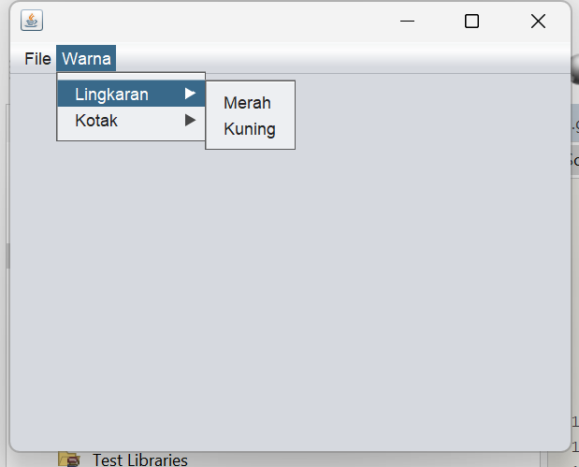
Script Code :
/*
* To change this license header, choose License Headers in Project Properties.
* To change this template file, choose Tools | Templates
* and open the template in the editor.
*/

/**
*
* @author Muhammad Rizal Nur F
*/
public class BP1_M3_P2_Rizal extends javax.swing.JFrame {

/**
* Creates new form BP1_M3_P2_Rizal
*/
public BP1_M3_P2_Rizal() {
initComponents();
}

/**
* This method is called from within the constructor to initialize the form.
* WARNING: Do NOT modify this code. The content of this method is always
* regenerated by the Form Editor.
*/
@SuppressWarnings("unchecked")
// <editor-fold defaultstate="collapsed" desc="Generated Code">
private void initComponents() {

jMenuBar1 = new javax.swing.JMenuBar();
jMenu1 = new javax.swing.JMenu();
jMenuItem1 = new javax.swing.JMenuItem();
jMenuItem2 = new javax.swing.JMenuItem();
jMenu2 = new javax.swing.JMenu();
jMenu4 = new javax.swing.JMenu();
jMenuItem3 = new javax.swing.JMenuItem();
jMenuItem6 = new javax.swing.JMenuItem();
jMenu5 = new javax.swing.JMenu();
jMenuItem4 = new javax.swing.JMenuItem();
jMenuItem5 = new javax.swing.JMenuItem();

setDefaultCloseOperation(javax.swing.WindowConstants.EXIT_ON_CLOSE);

jMenu1.setText("File");

jMenuItem1.setText("Buka");
jMenu1.add(jMenuItem1);

jMenuItem2.setText("Simpan");
jMenu1.add(jMenuItem2);

jMenuBar1.add(jMenu1);

jMenu2.setText("Warna");

jMenu4.setText("Lingkaran");

jMenuItem3.setText("Merah");
jMenuItem3.addActionListener(new java.awt.event.ActionListener() {
public void actionPerformed(java.awt.event.ActionEvent evt) {
jMenuItem3ActionPerformed(evt);
}
});
jMenu4.add(jMenuItem3);

jMenuItem6.setText("Kuning");
jMenuItem6.addActionListener(new java.awt.event.ActionListener() {
public void actionPerformed(java.awt.event.ActionEvent evt) {
jMenuItem6ActionPerformed(evt);
}
});
jMenu4.add(jMenuItem6);

jMenu2.add(jMenu4);

jMenu5.setText("Kotak");

jMenuItem4.setText("Merah");
jMenu5.add(jMenuItem4);

jMenuItem5.setText("Biru");
jMenuItem5.addActionListener(new java.awt.event.ActionListener() {
public void actionPerformed(java.awt.event.ActionEvent evt) {
jMenuItem5ActionPerformed(evt);
}
});
jMenu5.add(jMenuItem5);

jMenu2.add(jMenu5);

jMenuBar1.add(jMenu2);

setJMenuBar(jMenuBar1);

javax.swing.GroupLayout layout = new javax.swing.GroupLayout(getContentPane());
getContentPane().setLayout(layout);
layout.setHorizontalGroup(
layout.createParallelGroup(javax.swing.GroupLayout.Alignment.LEADING)
.addGap(0, 400, Short.MAX_VALUE)
);
layout.setVerticalGroup(
layout.createParallelGroup(javax.swing.GroupLayout.Alignment.LEADING)
.addGap(0, 269, Short.MAX_VALUE)
);

pack();
}// </editor-fold>

private void jMenuItem3ActionPerformed(java.awt.event.ActionEvent evt) {
// TODO add your handling code here:
}

private void jMenuItem6ActionPerformed(java.awt.event.ActionEvent evt) {
// TODO add your handling code here:
}

private void jMenuItem5ActionPerformed(java.awt.event.ActionEvent evt) {
// TODO add your handling code here:
}

/**
* @param args the command line arguments
*/
public static void main(String args[]) {
/* Set the Nimbus look and feel */
//<editor-fold defaultstate="collapsed" desc=" Look and feel setting code (optional) ">
/* If Nimbus (introduced in Java SE 6) is not available, stay with the default look and feel.
* For details see http://download.oracle.com/javase/tutorial/uiswing/lookandfeel/plaf.html
*/
try {
for (javax.swing.UIManager.LookAndFeelInfo info : javax.swing.UIManager.getInstalledLookAndFeels()) {
if ("Nimbus".equals(info.getName())) {
javax.swing.UIManager.setLookAndFeel(info.getClassName());
break;
}
}
} catch (ClassNotFoundException ex) {
java.util.logging.Logger.getLogger(BP1_M3_P2_Rizal.class.getName()).log(java.util.logging.Level.SEVERE, null, ex);
} catch (InstantiationException ex) {
java.util.logging.Logger.getLogger(BP1_M3_P2_Rizal.class.getName()).log(java.util.logging.Level.SEVERE, null, ex);
} catch (IllegalAccessException ex) {
java.util.logging.Logger.getLogger(BP1_M3_P2_Rizal.class.getName()).log(java.util.logging.Level.SEVERE, null, ex);
} catch (javax.swing.UnsupportedLookAndFeelException ex) {
java.util.logging.Logger.getLogger(BP1_M3_P2_Rizal.class.getName()).log(java.util.logging.Level.SEVERE, null, ex);
}
//</editor-fold>

/* Create and display the form */
java.awt.EventQueue.invokeLater(new Runnable() {
public void run() {
new BP1_M3_P2_Rizal().setVisible(true);
}
});
}

// Variables declaration - do not modify
private javax.swing.JMenu jMenu1;
private javax.swing.JMenu jMenu2;
private javax.swing.JMenu jMenu4;
private javax.swing.JMenu jMenu5;
private javax.swing.JMenuBar jMenuBar1;
private javax.swing.JMenuItem jMenuItem1;
private javax.swing.JMenuItem jMenuItem2;
private javax.swing.JMenuItem jMenuItem3;
private javax.swing.JMenuItem jMenuItem4;
private javax.swing.JMenuItem jMenuItem5;
private javax.swing.JMenuItem jMenuItem6;
// End of variables declaration
}
Post Test
- BP1_M3_PostTest1_Rizal_
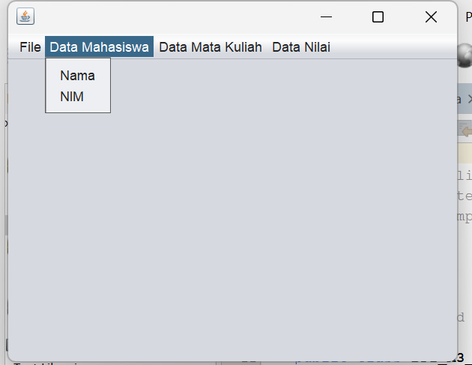

Script Code :
/*
* To change this license header, choose License Headers in Project Properties.
* To change this template file, choose Tools | Templates
* and open the template in the editor.
*/

/**
*
* @author Muhammad Rizal Nur F
*/
public class BP1_M3_PostTest1_Rizal extends javax.swing.JFrame {

/**
* Creates new form BP1_M3_PostTest1_Rizal
*/
public BP1_M3_PostTest1_Rizal() {
initComponents();
}

/**
* This method is called from within the constructor to initialize the form.
* WARNING: Do NOT modify this code. The content of this method is always
* regenerated by the Form Editor.
*/
@SuppressWarnings("unchecked")
// <editor-fold defaultstate="collapsed" desc="Generated Code">
private void initComponents() {

jMenuBar1 = new javax.swing.JMenuBar();
jMenu1 = new javax.swing.JMenu();
jMenuItem1 = new javax.swing.JMenuItem();
jMenuItem2 = new javax.swing.JMenuItem();
jMenu2 = new javax.swing.JMenu();
jMenuItem3 = new javax.swing.JMenuItem();
jMenuItem4 = new javax.swing.JMenuItem();
jMenu3 = new javax.swing.JMenu();
jMenuItem5 = new javax.swing.JMenuItem();
jMenuItem6 = new javax.swing.JMenuItem();
jMenu4 = new javax.swing.JMenu();
jMenuItem7 = new javax.swing.JMenuItem();
jMenuItem8 = new javax.swing.JMenuItem();

setDefaultCloseOperation(javax.swing.WindowConstants.EXIT_ON_CLOSE);

jMenu1.setText("File");
jMenu1.addMouseListener(new java.awt.event.MouseAdapter() {
public void mouseClicked(java.awt.event.MouseEvent evt) {
jMenu1MouseClicked(evt);
}
});

jMenuItem1.setText("Buka");
jMenuItem1.addMouseListener(new java.awt.event.MouseAdapter() {
public void mouseClicked(java.awt.event.MouseEvent evt) {
jMenuItem1MouseClicked(evt);
}
});
jMenu1.add(jMenuItem1);

jMenuItem2.setText("Simpan");
jMenuItem2.addMouseListener(new java.awt.event.MouseAdapter() {
public void mouseClicked(java.awt.event.MouseEvent evt) {
jMenuItem2MouseClicked(evt);
}
});
jMenu1.add(jMenuItem2);

jMenuBar1.add(jMenu1);

jMenu2.setText("Data Mahasiswa");
jMenu2.addMouseListener(new java.awt.event.MouseAdapter() {
public void mouseClicked(java.awt.event.MouseEvent evt) {
jMenu2MouseClicked(evt);
}
});

jMenuItem3.setText("Nama");
jMenuItem3.addMouseListener(new java.awt.event.MouseAdapter() {
public void mouseClicked(java.awt.event.MouseEvent evt) {
jMenuItem3MouseClicked(evt);
}
});
jMenu2.add(jMenuItem3);

jMenuItem4.setText("NIM");
jMenuItem4.addMouseListener(new java.awt.event.MouseAdapter() {
public void mouseClicked(java.awt.event.MouseEvent evt) {
jMenuItem4MouseClicked(evt);
}
});
jMenu2.add(jMenuItem4);

jMenuBar1.add(jMenu2);

jMenu3.setText("Data Mata Kuliah");
jMenu3.addMouseListener(new java.awt.event.MouseAdapter() {
public void mouseClicked(java.awt.event.MouseEvent evt) {
jMenu3MouseClicked(evt);
}
});

jMenuItem5.setText("Materi");
jMenuItem5.addMouseListener(new java.awt.event.MouseAdapter() {
public void mouseClicked(java.awt.event.MouseEvent evt) {
jMenuItem5MouseClicked(evt);
}
});
jMenu3.add(jMenuItem5);

jMenuItem6.setText("Praktikum");
jMenuItem6.addMouseListener(new java.awt.event.MouseAdapter() {
public void mouseClicked(java.awt.event.MouseEvent evt) {
jMenuItem6MouseClicked(evt);
}
});
jMenuItem6.addActionListener(new java.awt.event.ActionListener() {
public void actionPerformed(java.awt.event.ActionEvent evt) {
jMenuItem6ActionPerformed(evt);
}
});
jMenu3.add(jMenuItem6);

jMenuBar1.add(jMenu3);

jMenu4.setText("Data Nilai");
jMenu4.addMouseListener(new java.awt.event.MouseAdapter() {
public void mouseClicked(java.awt.event.MouseEvent evt) {
jMenu4MouseClicked(evt);
}
});

jMenuItem7.setText("Nilai UTS");
jMenuItem7.addMouseListener(new java.awt.event.MouseAdapter() {
public void mouseClicked(java.awt.event.MouseEvent evt) {
jMenuItem7MouseClicked(evt);
}
});
jMenu4.add(jMenuItem7);

jMenuItem8.setText("Nilai UAS");
jMenuItem8.addMouseListener(new java.awt.event.MouseAdapter() {
public void mouseClicked(java.awt.event.MouseEvent evt) {
jMenuItem8MouseClicked(evt);
}
});
jMenu4.add(jMenuItem8);

jMenuBar1.add(jMenu4);

setJMenuBar(jMenuBar1);

javax.swing.GroupLayout layout = new javax.swing.GroupLayout(getContentPane());
getContentPane().setLayout(layout);
layout.setHorizontalGroup(
layout.createParallelGroup(javax.swing.GroupLayout.Alignment.LEADING)
.addGap(0, 400, Short.MAX_VALUE)
);
layout.setVerticalGroup(
layout.createParallelGroup(javax.swing.GroupLayout.Alignment.LEADING)
.addGap(0, 269, Short.MAX_VALUE)
);

pack();
}// </editor-fold>

private void jMenuItem6ActionPerformed(java.awt.event.ActionEvent evt) {
// TODO add your handling code here:
}

private void jMenu1MouseClicked(java.awt.event.MouseEvent evt) {
// TODO add your handling code here:
}

private void jMenuItem1MouseClicked(java.awt.event.MouseEvent evt) {
// TODO add your handling code here:
}

private void jMenuItem2MouseClicked(java.awt.event.MouseEvent evt) {
// TODO add your handling code here:
}

private void jMenu2MouseClicked(java.awt.event.MouseEvent evt) {
// TODO add your handling code here:
}

private void jMenuItem3MouseClicked(java.awt.event.MouseEvent evt) {
// TODO add your handling code here:
}

private void jMenuItem4MouseClicked(java.awt.event.MouseEvent evt) {
// TODO add your handling code here:
}

private void jMenu3MouseClicked(java.awt.event.MouseEvent evt) {
// TODO add your handling code here:
}

private void jMenuItem5MouseClicked(java.awt.event.MouseEvent evt) {
// TODO add your handling code here:
}

private void jMenuItem6MouseClicked(java.awt.event.MouseEvent evt) {
// TODO add your handling code here:
}

private void jMenu4MouseClicked(java.awt.event.MouseEvent evt) {
// TODO add your handling code here:
}

private void jMenuItem7MouseClicked(java.awt.event.MouseEvent evt) {
// TODO add your handling code here:
}

private void jMenuItem8MouseClicked(java.awt.event.MouseEvent evt) {
// TODO add your handling code here:
}

/**
* @param args the command line arguments
*/
public static void main(String args[]) {
/* Set the Nimbus look and feel */
//<editor-fold defaultstate="collapsed" desc=" Look and feel setting code (optional) ">
/* If Nimbus (introduced in Java SE 6) is not available, stay with the default look and feel.
* For details see http://download.oracle.com/javase/tutorial/uiswing/lookandfeel/plaf.html
*/
try {
for (javax.swing.UIManager.LookAndFeelInfo info : javax.swing.UIManager.getInstalledLookAndFeels()) {
if ("Nimbus".equals(info.getName())) {
javax.swing.UIManager.setLookAndFeel(info.getClassName());
break;
}
}
} catch (ClassNotFoundException ex) {
java.util.logging.Logger.getLogger(BP1_M3_PostTest1_Rizal.class.getName()).log(java.util.logging.Level.SEVERE, null, ex);
} catch (InstantiationException ex) {
java.util.logging.Logger.getLogger(BP1_M3_PostTest1_Rizal.class.getName()).log(java.util.logging.Level.SEVERE, null, ex);
} catch (IllegalAccessException ex) {
java.util.logging.Logger.getLogger(BP1_M3_PostTest1_Rizal.class.getName()).log(java.util.logging.Level.SEVERE, null, ex);
} catch (javax.swing.UnsupportedLookAndFeelException ex) {
java.util.logging.Logger.getLogger(BP1_M3_PostTest1_Rizal.class.getName()).log(java.util.logging.Level.SEVERE, null, ex);
}
//</editor-fold>

/* Create and display the form */
java.awt.EventQueue.invokeLater(new Runnable() {
public void run() {
new BP1_M3_PostTest1_Rizal().setVisible(true);
}
});
}

// Variables declaration - do not modify
private javax.swing.JMenu jMenu1;
private javax.swing.JMenu jMenu2;
private javax.swing.JMenu jMenu3;
private javax.swing.JMenu jMenu4;
private javax.swing.JMenuBar jMenuBar1;
private javax.swing.JMenuItem jMenuItem1;
private javax.swing.JMenuItem jMenuItem2;
private javax.swing.JMenuItem jMenuItem3;
private javax.swing.JMenuItem jMenuItem4;
private javax.swing.JMenuItem jMenuItem5;
private javax.swing.JMenuItem jMenuItem6;
private javax.swing.JMenuItem jMenuItem7;
private javax.swing.JMenuItem jMenuItem8;
// End of variables declaration
}

Tugas
  - BP1_M2_Tugas1_Rizal_AppletePerhitungan
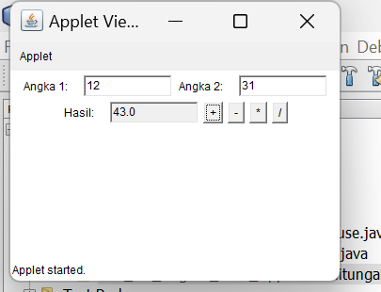

Script Code:
/*
* To change this license header, choose License Headers in Project Properties.
* To change this template file, choose Tools | Templates
* and open the template in the editor.
*/

import java.applet.Applet;
import java.awt.*;
import java.awt.event.*;

/**
*
* @author Muhammad Rizal Nur F
*/
public class BP1_M2_Tugas1_Rizal_AppletePerhitungan extends Applet implements ActionListener {
TextField input1, input2, result;
Button add, subtract, multiply, divide;

/**
* Initialization method that will be called after the applet is loaded into
* the browser.
*/
public void init() {
input1 = new TextField(10);
input2 = new TextField(10);
result = new TextField(10);
result.setEditable(false);

add = new Button("+");
subtract = new Button("-");
multiply = new Button("*");
divide = new Button("/");

add.addActionListener(this);
subtract.addActionListener(this);
multiply.addActionListener(this);
divide.addActionListener(this);

add(new Label("Angka 1:"));
add(input1);
add(new Label("Angka 2:"));
add(input2);
add(new Label("Hasil:"));
add(result);
add(add);
add(subtract);
add(multiply);
add(divide);
}

@Override
public void actionPerformed(ActionEvent e) {
try {
double num1 = Double.parseDouble(input1.getText());
double num2 = Double.parseDouble(input2.getText());
double hasil = 0;

if (e.getSource() == add) {
hasil = num1 + num2;
} else if (e.getSource() == subtract) {
hasil = num1 - num2;
} else if (e.getSource() == multiply) {
hasil = num1 * num2;
} else if (e.getSource() == divide) {
if (num2 != 0) {
hasil = num1 / num2;
} else {
result.setText("Error: Division by zero");
return;
}
}

result.setText(String.valueOf(hasil));
} catch (NumberFormatException ex) {
result.setText("Input tidak valid");
}
}
// TODO start asynchronous download of heavy resources
// TODO overwrite start(), stop() and destroy() methods
}
Analisis:
Program ini menggunakan TextField untuk menerima input angka dan menampilkan hasil.
Empat tombol digunakan untuk operasi aritmatika: penjumlahan (+), pengurangan (-), perkalian (*), dan pembagian (/).
Hasil perhitungan ditampilkan di TextField hasil, dan kesalahan input atau pembagian oleh nol ditangani.

- BP1_M2_Tugas2_Rizal_AppleteAnimasi
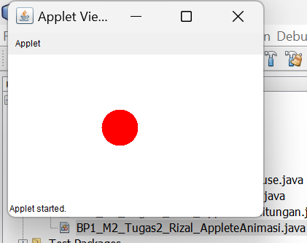
Script Code :
/*
* To change this license header, choose License Headers in Project Properties.
* To change this template file, choose Tools | Templates
* and open the template in the editor.
*/

import java.applet.Applet;
import java.awt.*;

/**
*
* @author Muhammad Rizal Nur F
*/
public class BP1_M2_Tugas2_Rizal_AppleteAnimasi extends Applet implements Runnable {
private int x = 0;
private int dx = 2;
private Thread animasiThread;
/**
* Initialization method that will be called after the applet is loaded into
* the browser.
*/
@Override
public void init() {
setBackground(Color.white);
}

@Override
public void start() {
animasiThread = new Thread(this);
animasiThread.start();
}

@Override
public void run() {
while (true) {
x += dx;
if (x < 0 || x > getWidth() - 50) {
dx = -dx;
}
repaint();
try {
Thread.sleep(50);
} catch (InterruptedException e) {
e.printStackTrace();
}
}
}

@Override
public void paint(Graphics g) {
g.setColor(Color.red);
g.fillOval(x, getHeight() / 2 - 25, 50, 50);
}

@Override
public void stop() {
animasiThread = null;
}
// TODO start asynchronous download of heavy resources

// TODO overwrite start(), stop() and destroy() methods
}
Analisis :
Lingkaran Digambar yang berwarna merah pada posisi x yang berubah seiring waktu untuk menciptakan animasi, dx menentukan kecepatan gerak dan arah lingkaran.
Ketika lingkaran mencapai batas kanan atau kiri, arah geraknya dibalik, membuatnya bergerak bolak-balik.

